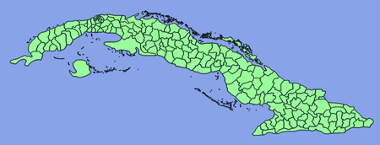

Island:
The natural resources of the island include nickel, iron ore, cobalt, chromium, silica, copper, and petroleum.
Population: 11.27 million

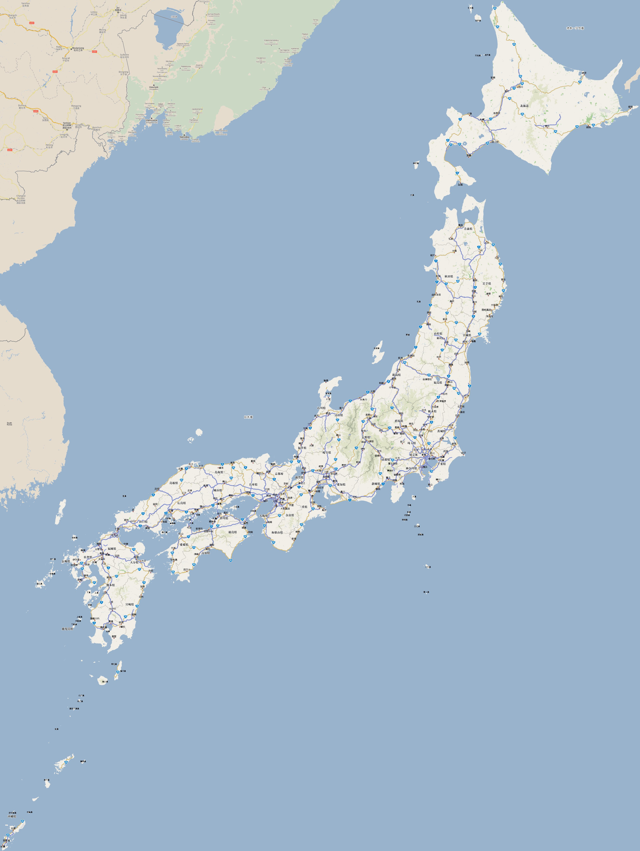
Island:
The natural resources of the island include fish, strong industrial output, agriculture and small amounts of metals and minerals.
Population: 127.3 million
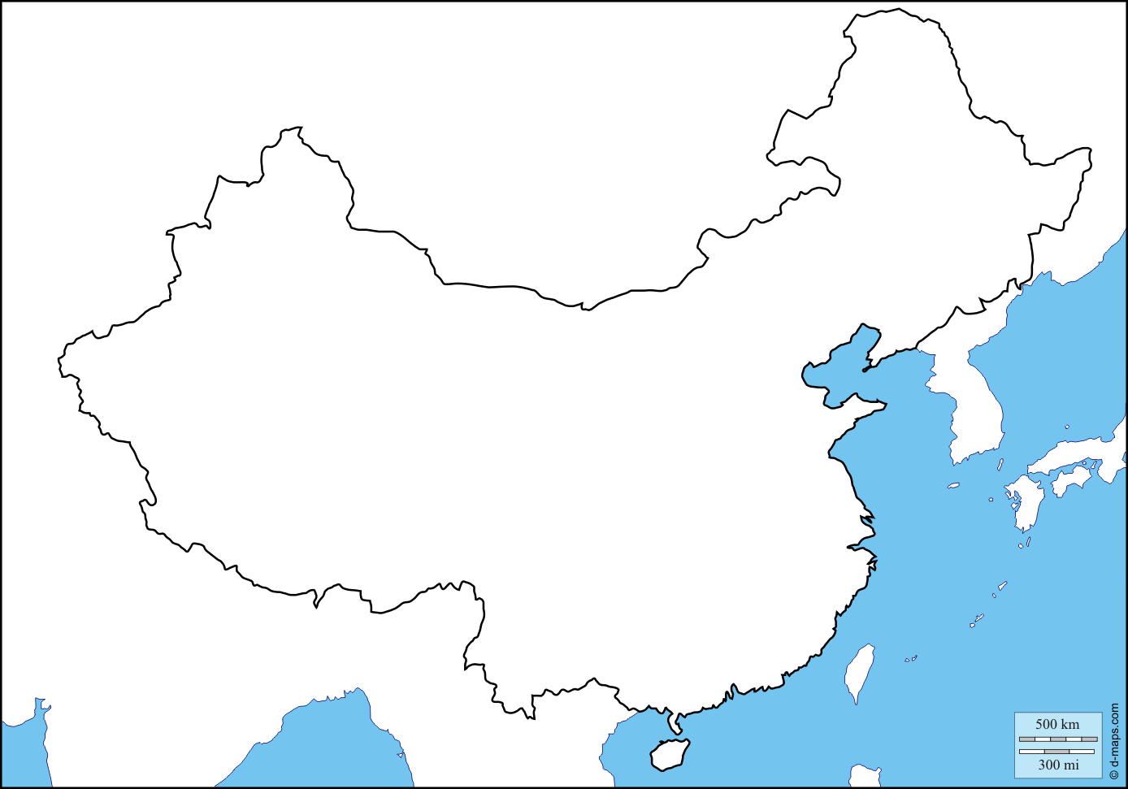
Mainland:
Natural Resources: The country has about 12 percent of the world's mineral resources. There are sizeable reserves of coal, iron, tin, copper, lead, zinc, molybdenum, tungsten, mercury, graphite, antimony, magnesite, and fluorspar.

Population: 1.357 billion

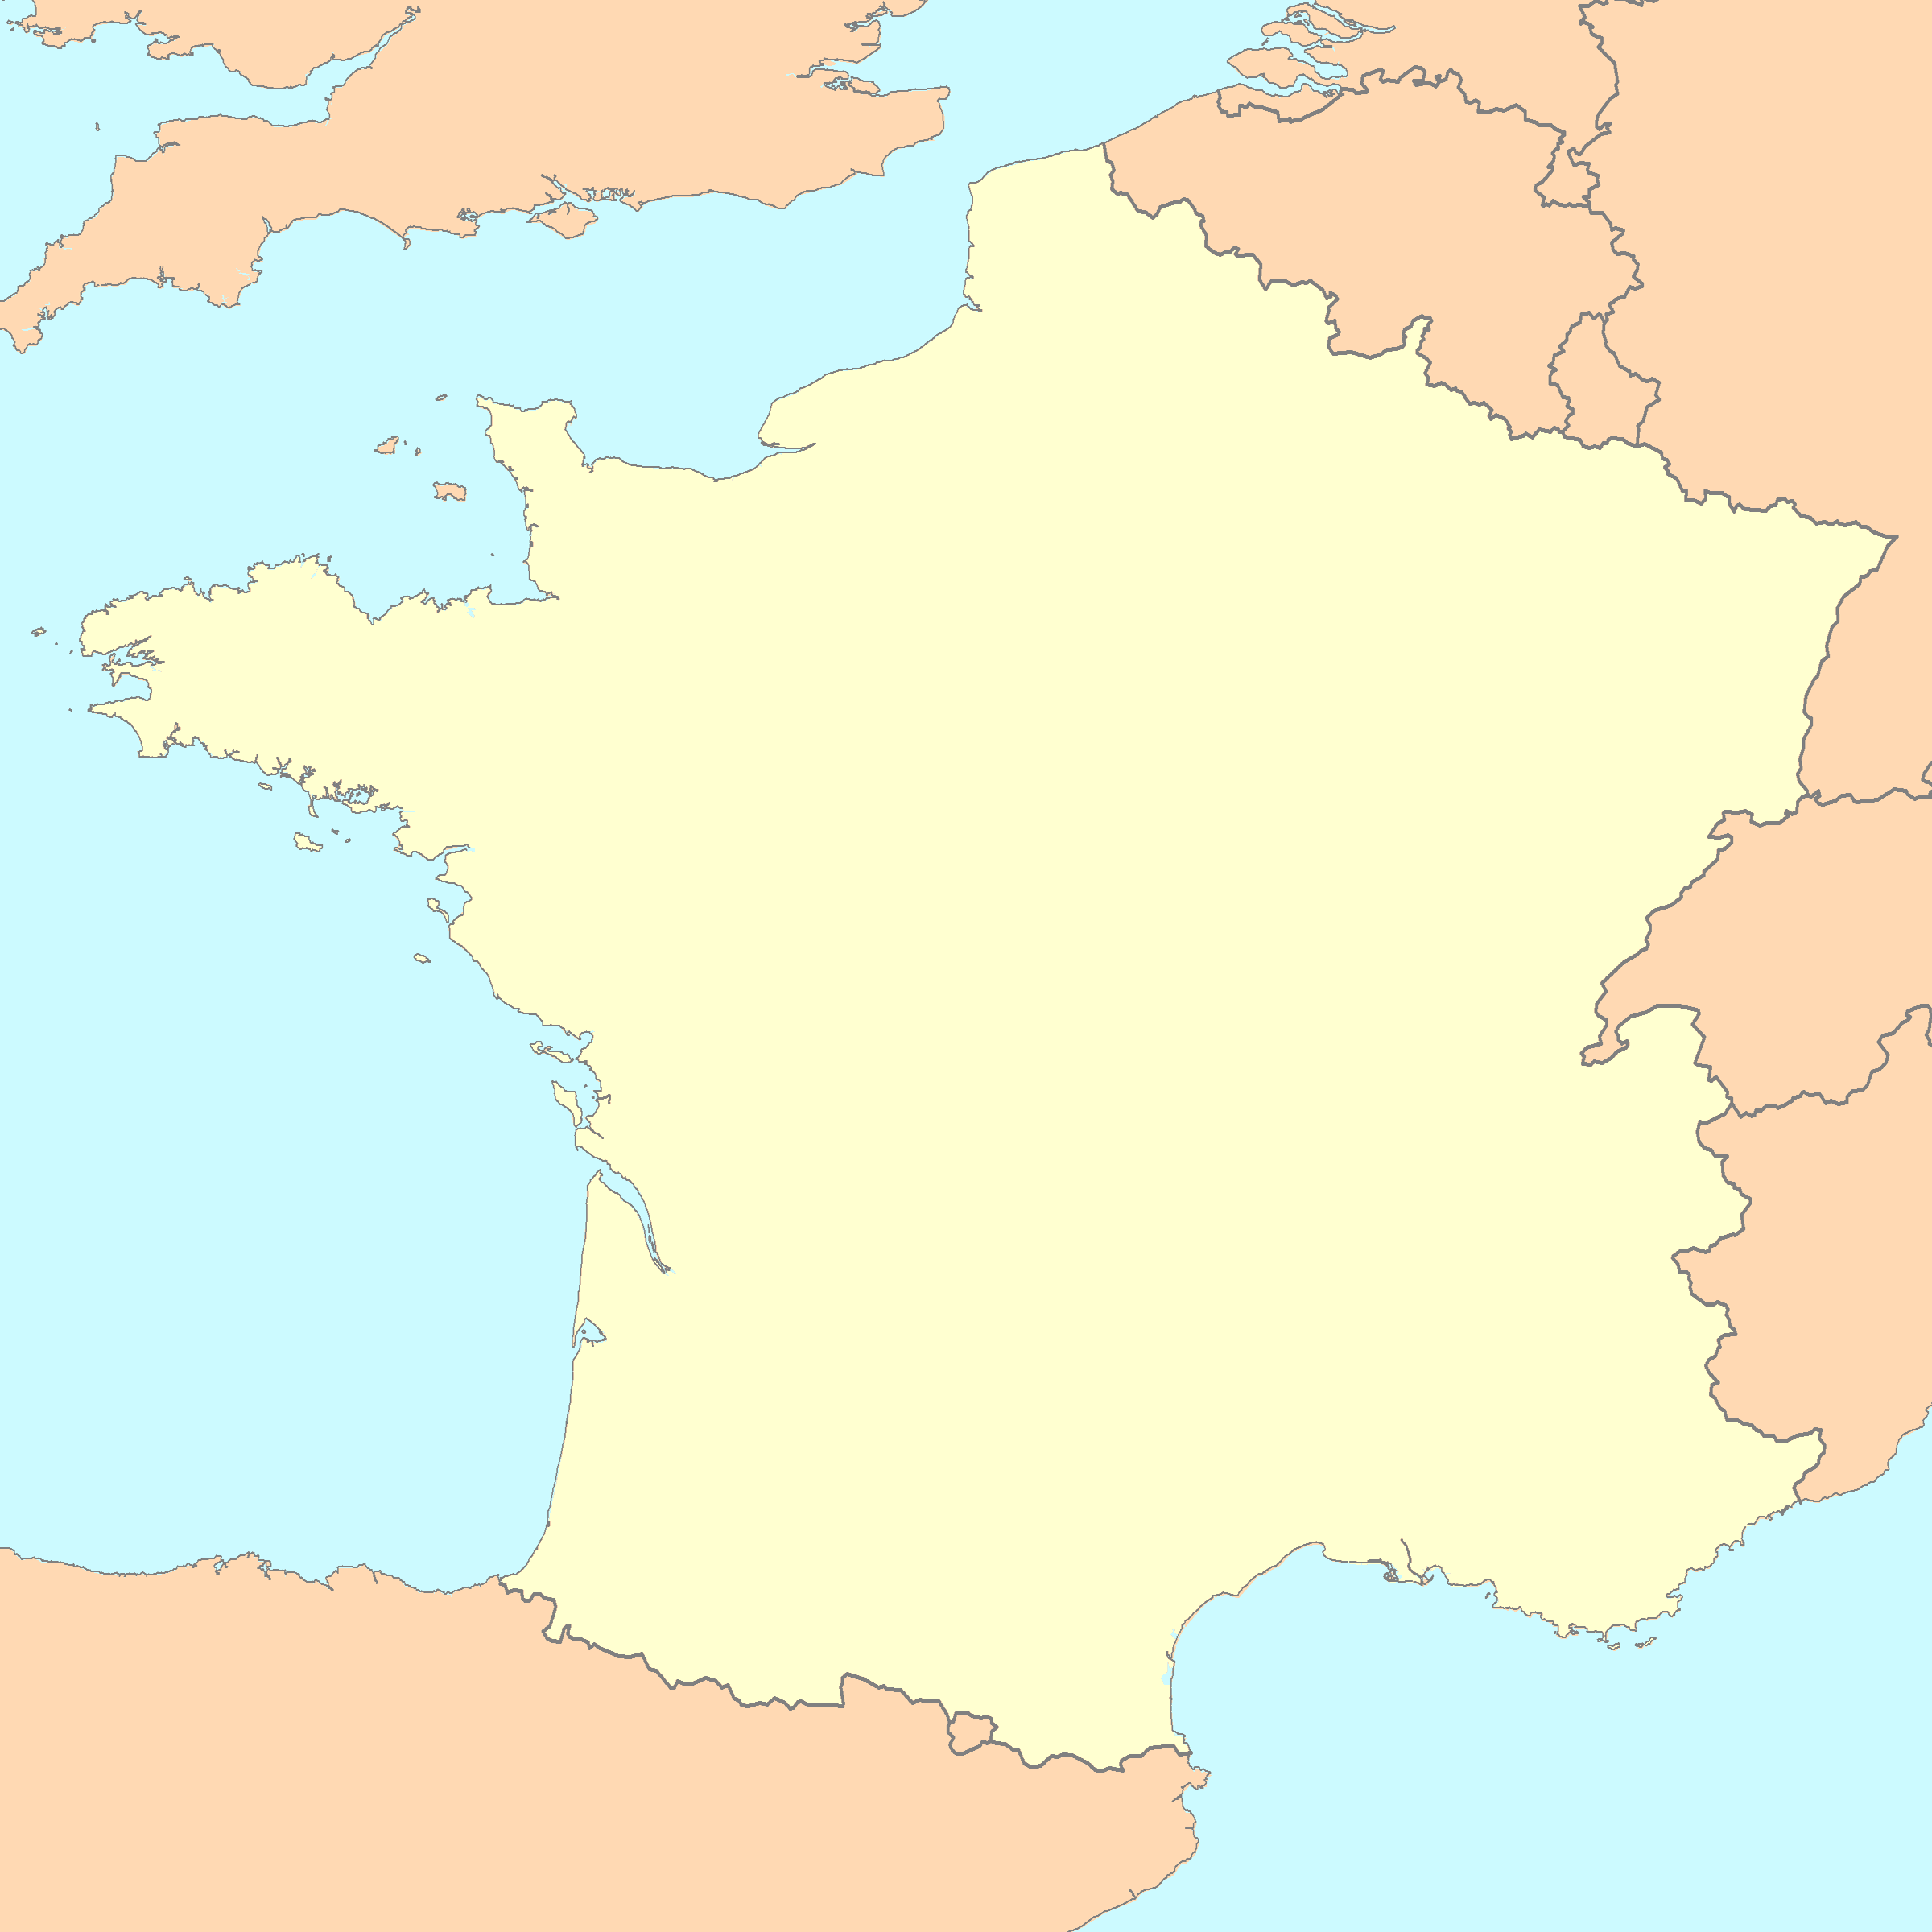
Mainland:

Natural Resources: are iron ore, salt, sulfur, bauxite, zinc, uranium, antimony, arsenic, potash, feldspar, fluorspar and gypsum.

Population: 66.03 million

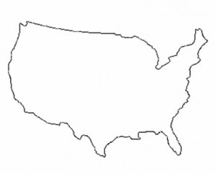
Mainland:
Natural Resources: has huge deposits of natural gas, coal, uranium, copper, iron, phosphates, silver, gold, mercury, zinc, lead, bauxite, molybdenum, nickel, petroleum,
Population: 318.9 million

Task: You are to choose an economic system for your Nation,
- Base your economic system on Population, Resources, and location.
- Answer the 3 main questions of an economic system.
- Analyze your natural resources to create products.
- Explain why your economic system would benefit your nation.

